Case Study: Container Security Risks and Attack Propagation in Cloud-Native Environments

Title
Container Security Risks and Attack Propagation in Cloud-Native Environments: A Case Study of a Kubernetes-Based E-Commerce Platform

Abstract
Cloud-native applications rely on containers and orchestration platforms such as Kubernetes for scalability and rapid deployment. However, misconfigured containers, vulnerable images, and weak access controls can enable attackers to compromise workloads and move laterally across the environment. This case study examines a simulated attack on a Kubernetes-hosted e-commerce application, identifies security weaknesses, analyzes attack propagation, and recommends mitigation strategies.

1. Introduction
Containerization has transformed modern software development by enabling lightweight, portable, and scalable applications. Platforms such as Docker and Kubernetes have become industry standards for deploying cloud-native applications. Despite these benefits, containers introduce unique security risks. Since containers share the host operating system kernel, a single vulnerability or misconfiguration can potentially affect multiple services.
This case study investigates how an attacker exploits a vulnerable container and propagates through a cloud-native infrastructure.

2. Background
Organization: ABC Online Retail Pvt. Ltd.
Industry: E-commerce
Cloud Platform: AWS
Container Runtime: Docker
Orchestration: Kubernetes (Amazon EKS)
Monitoring: Prometheus + Grafana
Logging: ELK Stack
Registry: Docker Hub (Public Images)

3. Problem Statement
ABC Online Retail migrated its monolithic application to Kubernetes to improve scalability. Shortly after deployment, suspicious network traffic and unauthorized access attempts were detected.
The security team suspected that attackers had compromised one of the application containers and moved laterally across the cluster.

4. Objectives
- Identify container security vulnerabilities.
- Analyze how attackers propagated within Kubernetes.
- Assess business impact.
- Recommend security controls to prevent similar attacks.

5. Cloud Architecture
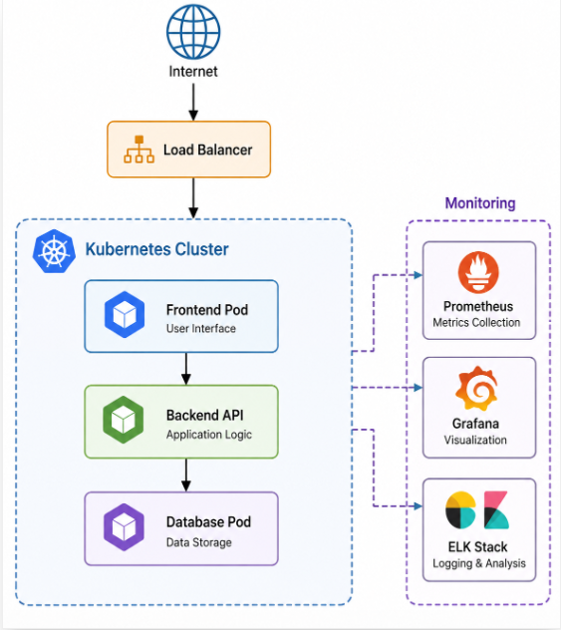

6. Identified Security Risks

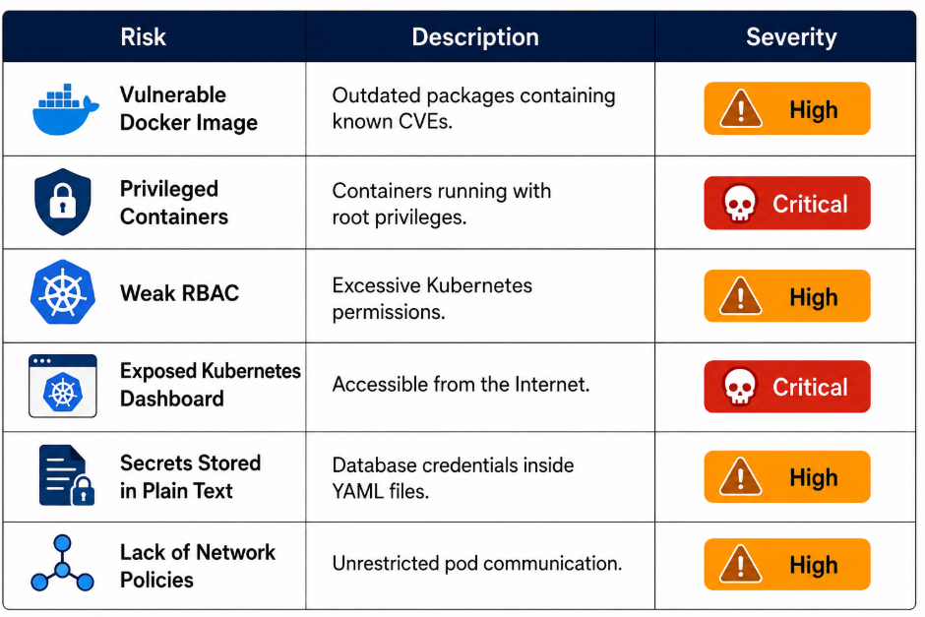

7. Attack Scenario
Phase 1: Initial Compromise
The attacker scans the application and discovers a vulnerable web service.
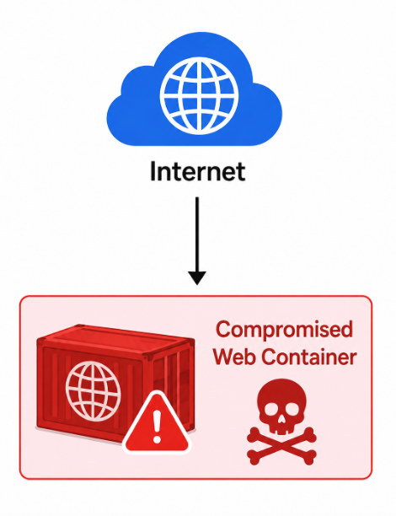
Phase 2: Container Exploitation
The attacker exploits a Remote Code Execution (RCE) vulnerability.
Example:
CVE-2021-44228 (Log4Shell)
The attacker gains shell access inside the container.

Phase 3: Credential Theft
The attacker finds Kubernetes service account tokens.
/var/run/secrets/kubernetes.io/serviceaccount/token
These credentials allow interaction with the Kubernetes API.

Phase 4: Privilege Escalation
Due to overly permissive RBAC rules:
ClusterRole = cluster-admin
The attacker gains administrator privileges.

Phase 5: Lateral Movement
The attacker accesses:
- Backend containers
- Database pod
- Internal APIs
- Storage volumes
Because no Kubernetes Network Policies exist, communication is unrestricted.

Phase 6: Data Exfiltration
Sensitive customer information is copied.
Examples:
- Customer names
- Email addresses
- Payment metadata
- Order history

8. Attack Propagation Diagram
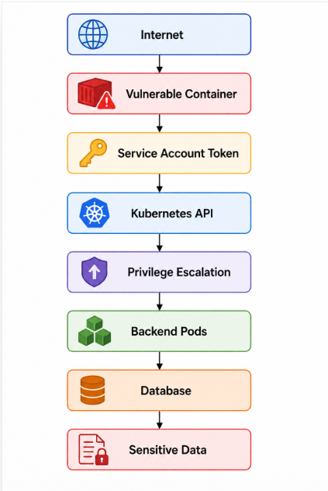
9. Impact Analysis
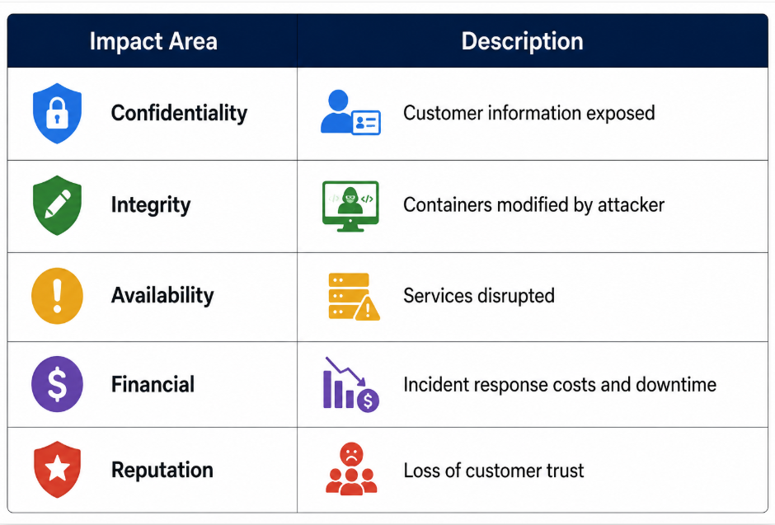
10. Root Cause Analysis
The investigation identified multiple security failures:
- Outdated container images
- Containers running as root
- Excessive Kubernetes permissions
- Secrets stored insecurely
- Missing network segmentation
- Lack of runtime monitoring

11. Mitigation Strategies
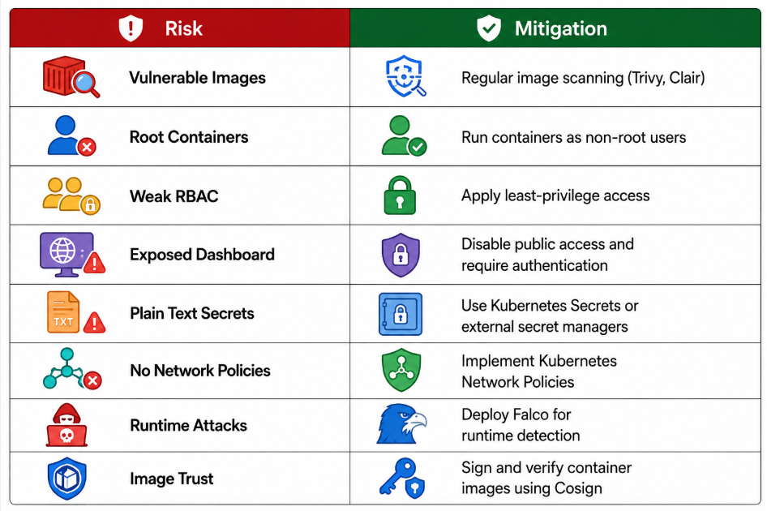12. Best Practices
- Scan container images before deployment.
- Use minimal base images (e.g., Alpine, Distroless).
- Enforce Role-Based Access Control (RBAC).
- Store secrets securely using a secret management solution.
- Enable admission controllers and Pod Security Standards.
- Continuously monitor containers with Falco or similar tools.
- Keep Kubernetes and container runtimes updated.
- Implement zero-trust networking with Network Policies.

13. Lessons Learned
- A single vulnerable container can become the entry point for compromising an entire Kubernetes cluster.
- Excessive permissions and poor network segmentation significantly accelerate attack propagation.
- Continuous vulnerability scanning, runtime monitoring, and least-privilege access are essential for securing cloud-native environments.

14. Conclusion
This case study demonstrates how attackers can exploit a vulnerable container to gain access to a Kubernetes cluster, escalate privileges, move laterally, and exfiltrate sensitive data. The primary causes were insecure container configurations, outdated images, excessive RBAC permissions, and inadequate network isolation. Implementing defense-in-depth controls—including secure image management, least-privilege access, network policies, secrets management, and continuous monitoring—substantially reduces the likelihood and impact of such attacks.

References
- Cloud Native Computing Foundation Kubernetes Security Best Practices.
- Open Worldwide Application Security Project Docker Security Cheat Sheet.
- National Institute of Standards and Technology SP 800-190: Application Container Security Guide.
- MITRE ATT&CK Framework.
- Center for Internet Security Kubernetes Benchmark.

